* **Lab Task 3**

Write a SQL statement that uses a subquery to display the country code, airport name, and city of airports in countries with a population greater than 200 million.

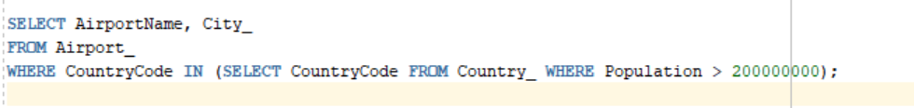

OUTPUT:

